⭐⭐ZERO WASTE FOOD CHALLENGE WORKSHOPS⭐⭐

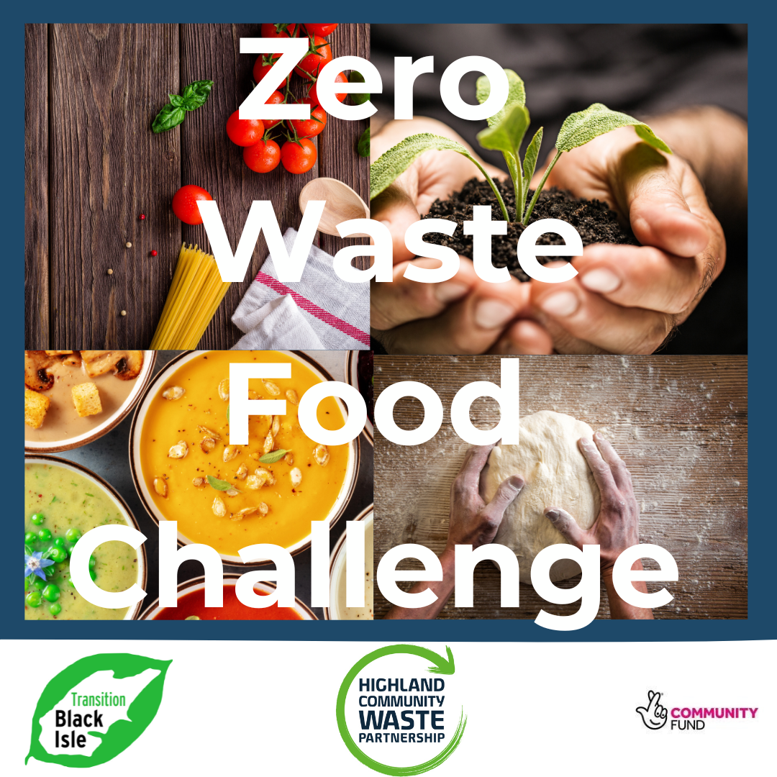

We've partnered with some fantastic local businesses, people and groups to bring you this 6 week block of fun & creative workshops to help reduce food waste, save money and learn some new skills.

🌿 **BATCH COOKING** with Fuggo from Highland Good Food Partnership

🌿 **MAKE YOUR OWN FAKEAWAY PIZZA** with Nikky from Strathpeffer Artisan Bread

🌿 **GROWING & STORING YOUR OWN FOOD** with Konia from Garden Joy in the Highlands & MOO Food

🌿 **FERMENTING & PICKLING** with Fuggo from Highland Good Food Partnership

🌿 **COOKING WITH LEFTOVERS** with Debbie from Highland Homecook

🌿 **COMPOSTING** with Konia from Garden Joy in the Highlands & MOO Food

We recommend booking all 6 of the workshops so as to get the benefit of the whole food waste journey but if you cannot attend every week, you are still welcome to join the challenge and book the individual workshops that work for you.

To secure your place, please book the session(s) you wish to attend via Ticket Tailor 👇👇

<https://buytickets.at/transitionblackisle>

All workshops & resources are free thanks to funding from Highland Community Waste Partnership. Each person attending a workshop will receive handy tools to make reducing food waste easier too.

